Compass with CID via HSCAN – CGEA1.3

Functional Description

This document describes the interactions between instrument cluster and BCM (SPDJB). In CGEA, there is a LIN based compass that is networked to the SPDJB. The SPDJB acts as a HSCAN to LIN gateway, and will send compass display information over HSCAN. The CID will display the directional heading of the vehicle as one of the following headings: North, Northeast, East, Southeast, South, Southwest, West, or Northwest. It will also display special modes, including calibration and zone setting, as well as the compass zones.

Note that this architecture supports zone and calibration selection through the CID. The compass module itself does not have a button, therefore the CID is the only way for the driver to initiate a zone change or a manual calibration.

This STSS applies to CGEA programs that have decided to have the compass display in the Cockpit Integrated Display (CID) module. The cluster has to interface with a legacy CID module, and also uses button presses from the FCIM.

Interfaces

Interface Context Diagram (I/O Block Diagram)

Figure 1: Compass Context Diagram

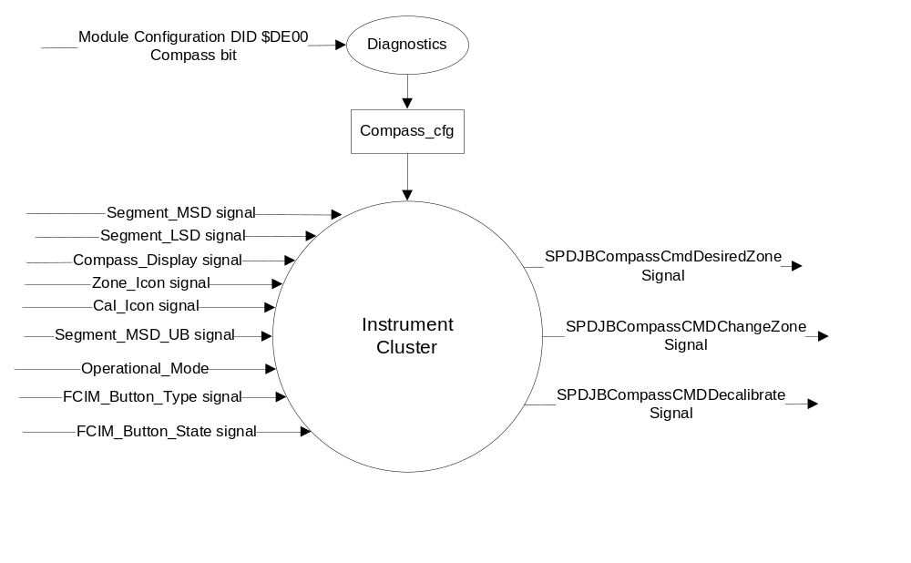

Inputs

Internal

Operational_Mode

Mux Message from the CAN bus

Table 1.0 CAN Input Signal Details (0x3C7)

Signal Name | Size (bits) | Pos. (bits) | Detail | Units | Res. | Offset | State Encoded | Min | Max
Segment_MSD | 8 | 0 |  | Dimensionless | 1 | 0 |  | 0 (0x0) | 254 (0xFE)
Segment_LSD | 8 | 8 |  | Dimensionless | 1 | 0 |  | 0 (0x0) | 254 (0xFE)
Compass_ Display | 1 | 16 |  | SED | 1 | 0 |  | 0 (0x0) | 1 (0x1)
 |  |  | Off |  |  |  | 0x0
 |  |  | On |  |  |  | 0x1
Zone_Icon | 1 | 17 |  | SED | 1 | 0 |  | 0 (0x0) | 1 (0x1)
 |  |  | Off |  |  |  | 0x0
 |  |  | On |  |  |  | 0x1
Cal_Icon | 1 | 18 |  |  | 1 | 0 |  | 0 (0x0) | 1 (0x1)
 |  |  | Off |  |  |  | 0x0
 |  |  | On |  |  |  | 0x1
Segment_MSD_UB | 1 | 34 |  | SED | 1 | 0 |  | 0 (0x0) | 1 (0x1)
 |  |  | Unchanged_data |  |  |  | 0x0
 |  |  | Fresh_data |  |  |  | 0x1
Segment_LSD_UB | 1 | 35 |  | SED | 1 | 0 |  | 0 (0x0) | 1 (0x1)
 |  |  | Unchanged_data |  |  |  | 0x0
 |  |  | Fresh_data |  |  |  | 0x1
Compass_ Display_UB | 1 | 36 |  | SED | 1 | 0 |  | 0 (0x0) | 1 (0x1)
 |  |  | Unchanged_data |  |  |  | 0x0
 |  |  | Fresh_data |  |  |  | 0x1
Zone_Icon_UB | 1 | 37 |  | SED | 1 | 0 |  | 0 (0x0) | 1 (0x1)
 |  |  | Unchanged_data |  |  |  | 0x0
 |  |  | Fresh_data |  |  |  | 0x1
Cal_Icon_UB | 1 | 38 |  | SED | 1 | 0 |  | 0 (0x0) | 1 (0x1)
 |  |  | Unchanged_data |  |  |  | 0x0
 |  |  | Fresh_data |  |  |  | 0x1

Where:
Signal Name | Received Byte Value | Description
 | 0x00 | Invalid
 | 0x20
 | 0x2D | -
 | 0X30 | 0
 | 0X31 | 1
 | 0X32 | 2
 | 0X33 | 3
 | 0X34 | 4
Segment_MSD | 0X35 | 5
 | 0X36 | 6
 | 0X37 | 7
 | 0X38 | 8
 | 0X39 | 9
 | 0X45 | E
 | 0x4E | N
 | 0X53 | S
 | 0X57 | W
 | 0xFF | Invalid
 | 0x00 | Invalid
 | 0x20
 | 0x2D | -
 | 0X30 | 0
 | 0X31 | 1
 | 0X32 | 2
 | 0X33 | 3
 | 0X34 | 4
Segment_LSD | 0X35 | 5
 | 0X36 | 6
 | 0X37 | 7
 | 0X38 | 8
 | 0X39 | 9
 | 0X45 | E
 | 0x4E | N
 | 0X53 | S
 | 0X57 | W
 | 0xFF | Invalid

Table 1.1 CAN Input Signal Details (0x2E0)

Signal Name | Size (bits) | Pos. (bits) | Detail | Units | Res. | Offset | State Encoded | Min | Max
FCIM_Button_Type | 8 | 0 |  | SED | 1 | 0 |  | 0 (0x0) | 255 (0xFF)
 |  |  | Compass_Cal |  |  |  | 0x7A
FCIM_Button_State | 2 | 8 |  | SED | 1 | 0 |  | 0 (0x0) | 3 (0x3)
 |  |  | NOP |  |  |  | 0x0
 |  |  | Button_Released |  |  |  | 0x1
 |  |  | Button_Pressed |  |  |  | 0x2

Outputs

Mux Message from the CAN bus

Table 1.2 CAN Output Signal Details

Signal Name | Size (bits) | Pos. (bits) | Detail | Units | Res. | Offset | State Encoded | Min | Max
SPDJBCompassCmdDesiredZone | 4 | 48 |  | SED | 1 | 0 |  | 0 (0x0) | 15 (0xF)
 |  |  | Zone 1 |  |  |  | $01
 |  |  | Zone 2 |  |  |  | $02
 |  |  | Zone 3 |  |  |  | $03
 |  |  | Zone 4 |  |  |  | $04
 |  |  | Zone 5 |  |  |  | $05
 |  |  | Zone 6 |  |  |  | $06
 |  |  | Zone 7 |  |  |  | $07
 |  |  | Zone 8 |  |  |  | $08
 |  |  | Zone 9 |  |  |  | $09
 |  |  | Zone 10 |  |  |  | $0A
 |  |  | Zone 11 |  |  |  | $0B
 |  |  | Zone 12 |  |  |  | $0C
 |  |  | Zone 13 |  |  |  | $0D
 |  |  | Zone 14 |  |  |  | $0E
 |  |  | Zone 15 |  |  |  | $0F
SPDJBCompassCMDChangeZone | 1 | 52 |  |  | 1 | 0 |  | 0 (0x0) | 1 (0x1)
 |  |  | No |  |  |  | 0x0
 |  |  | Yes |  |  |  | 0x1
SPDJBCompassCMDDecalibrate | 1 | 53 |  |  | 1 | 0 |  | 0 (0x0) | 1 (0x1)
 |  |  | No |  |  |  | 0x0
 |  |  | Yes |  |  |  | 0x1

Function/Performance

Operational Modes

Mode | Differentiating Vehicle Conditions
Sleep Mode | Compass Function OFF
Limited Mode | Compass Function OFF
Normal Mode | Compass Function ON
Crank Mode | Compass Function OFF

Voltage Levels

Refer to the Cluster Features Table located in the Operational Modes and Voltage Range Strategies section of this SPSS.

Human-Machine Interface

Visual

None

Audio

None

Switch Control Logic

None

System Accuracy

None

Operation: Performance and Functional

Subsystem Algorithm Flowchart / State Diagram

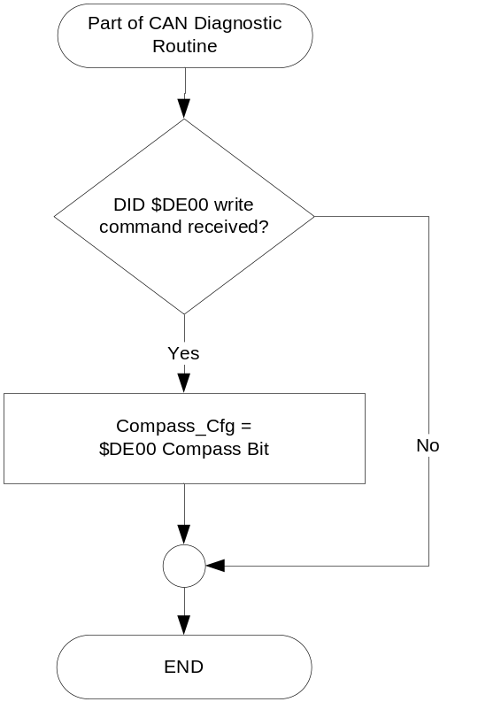

Compass with CID State Diagram

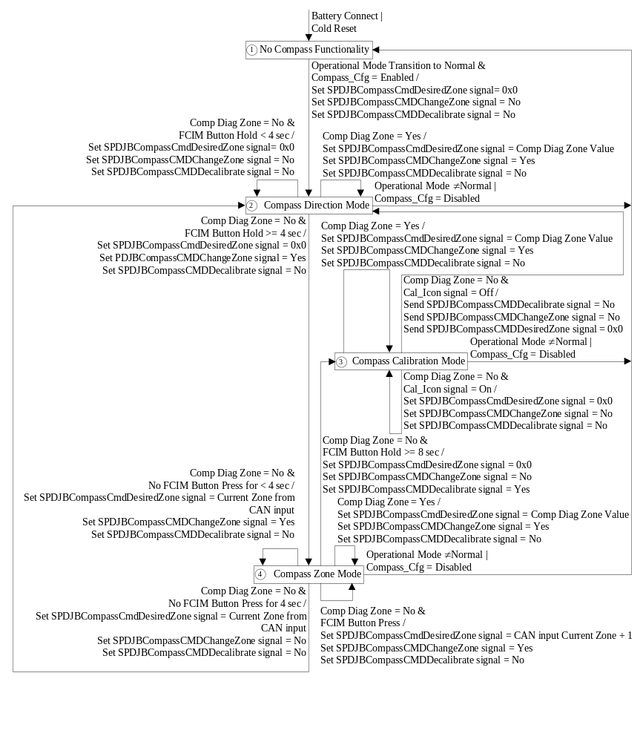
FCIM Button Press = (FCIM_Button_Type signal = Compass_Cal) AND (FCIM_Button_State signal = Button_Pressed)

FCIM Button Release = (FCIM_Button_Type signal != Compass_Cal) OR (FCIM_Button_State signal != Button_Pressed)

FCIM Button Hold = Timer that starts on every FCIM Button Press, and is cleared on every FCIM Button Release.

Compass Diagnostic Routine

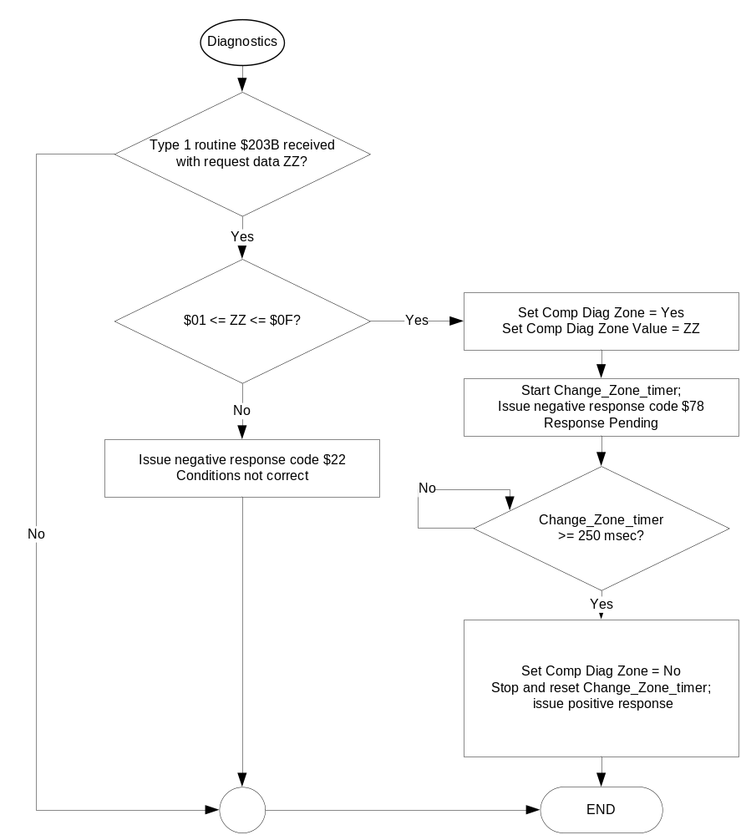
Table 1.3 _CMPS_FDM_Info_Status lookup table

Operational_ Mode | Segment_  MSD | Segment_  LSD | Compass_  Display | Zone_  Icon | Cal_  Icon | Compass Data
 | 0x4E | 0x20 | 0x1 | 0x0 | 0x0 | NORTH
 | 0x4E | 0X45 | 0X1 | 0X0 | 0X0 | NORTHEAST
 | 0x20 | 0x45 | 0X1 | 0X0 | 0X0 | EAST
 | 0X53 | 0X45 | 0X1 | 0X0 | 0X0 | SOUTHEAST
 | 0X53 | 0X20 | 0X1 | 0X0 | 0X0 | SOUTH
 | 0X53 | 0X57 | 0X1 | 0x0 | 0X0 | SOUTHWEST
 | 0X20 | 0X57 | 0X1 | 0X0 | 0X0 | WEST
 | 0X4E | 0X57 | 0X1 | 0X0 | 0X0 | NORTHWEST
 | 0X20 | 0x20 | 0x1 | 0x0 | 0X1 | CAL
 | 0X20 or  0x30 | 0X31 | 0x1 | 0X1 | 0X0 | ZONE 1
 | 0X20 or  0x30 | 0X32 | 0X1 | 0X1 | 0X0 | ZONE 2
 | 0X20 or  0x30 | 0X33 | 0X1 | 0X1 | 0X0 | ZONE 3
 | 0X20 or  0x30 | 0X34 | 0X1 | 0X1 | 0X0 | ZONE 4
Normal | 0X20 or  0x30 | 0X35 | 0X1 | 0X1 | 0X0 | ZONE 5
 | 0X20 or  0x30 | 0X36 | 0X1 | 0X1 | 0X0 | ZONE 6
 | 0X20 or  0x30 | 0X37 | 0X1 | 0X1 | 0X0 | ZONE 7
 | 0X20 or  0x30 | 0X38 | 0X1 | 0X1 | 0X0 | ZONE 8
 | 0X20 or  0x30 | 0X39 | 0X1 | 0X1 | 0X0 | ZONE 9
 | 0X31 | 0X30 | 0X1 | 0X1 | 0X0 | ZONE 10
 | 0X31 | 0X31 | 0X1 | 0X1 | 0X0 | ZONE 11
 | 0X31 | 0X32 | 0X1 | 0X1 | 0X0 | ZONE 12
 | 0X31 | 0X33 | 0X1 | 0X1 | 0X0 | ZONE 13
 | 0X31 | 0X34 | 0X1 | 0X1 | 0X0 | ZONE 14
 | 0X31 | 0X35 | 0X1 | 0X1 | 0X0 | ZONE 15
 | 0x2D | 0x2D | 0x1 | 0x0 | 0x0 | --
 | 0X20 | 0X20 | 0X0 | 0X0 | 0X0 | OFF (no display)
All Other Cases including Never Received |  |  |  |  |  | OFF (no display)

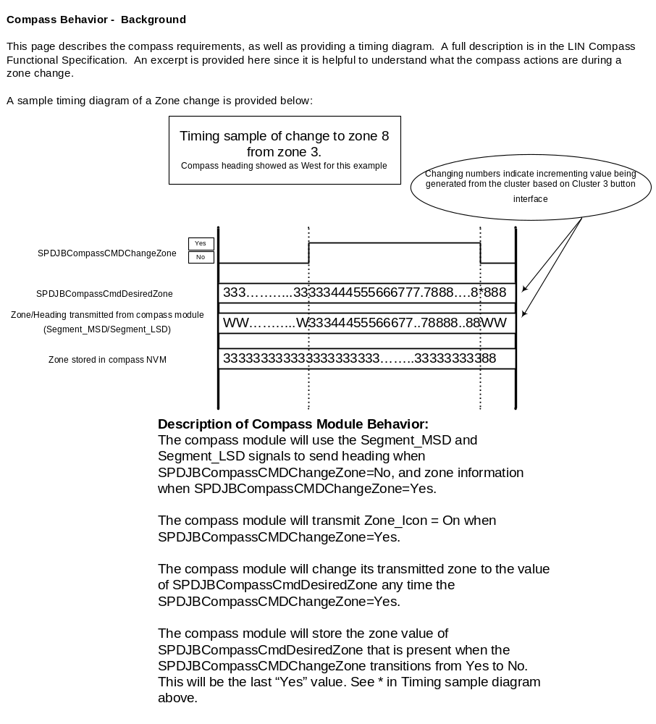

Operation Description (supports algorithm flowchart /state diagram)

- The electronic compass shall be operational when the ignition switch is in the RUN position only.

Function Safety Classification (EMC)

Class B

Memory Storage

Table 1.4 Compass Display Memory Storage
Parameter Name | Description | Value at Battery Connect | Value at Module Wake-up
SPDJBCompassCmdDesiredZone | Output signal to Compass through SPDJB for desired Zone | 0x0 | 0x0
SPDJBCompassCMDChangeZone | Output signal to Compass through SPDJB to command zone to change | 0x0 (No) | 0x0 (No)
SPDJBCompassCMDDecalibrate | Output signal to Compass through SPDJB to command zone to initiate a manual calibration | 0x0 (No) | 0x0 (No)
Segment_MSD signal | Input signal from SPDJB (0x3C7 HS_CAN message) | 0x20 | 0x20
Segment_LSD signal | Input signal from SPDJB (0x3C7 HS_CAN message) | 0x20 | 0x20
Compass_Display signal | Input signal from SPDJB (0x3C7 HS_CAN message) | 0x0 | 0x0
Zone_Icon signal | Input signal from SPDJB (0x3C7 HS_CAN message) | 0x0 | 0x0
Cal_Icon signal | Input signal from SPDJB (0x3C7 HS_CAN message) | 0x0 | 0x0
Segment_MSD_UB signal | Input signal from SPDJB (0x3C7 HS_CAN message) | 0x0 | 0x0
Segment_LSD_UB signal | Input signal from SPDJB (0x3C7 HS_CAN message) | 0x0 | 0x0
Compass_ Display_UB signal | Input signal from SPDJB (0x3C7 HS_CAN message) | 0x0 | 0x0
Zone_Icon_UB signal | Input signal from SPDJB (0x3C7 HS_CAN message) | 0x0 | 0x0
Cal_Icon_UB signal | Input signal from SPDJB (0x3C7 HS_CAN message) | 0x0 | 0x0
FCIM_Button_Type signal | Input signal from SPDJB (from 0x2E0 HS_CAN message) | 0x0 | 0x0
FCIM_Button_State signal | Input signal from SPDJB (from 0x2E0 HS_CAN message) | 0x0 | 0x0
Operational_Mode | 4 state indicator for cluster operational mode | Limited | Limited or Normal or Crank
Comp Diag Zone | Flag used to support EOL Diag Routine | No | No
FCIM Button Hold Timer | Timer used to set compass states. | 0s | 0s

Prove Out

No

Reconfigurable Telltale

Not applicable.

Message Center Msg

Not applicable.

Error Handling

Missing Message Strategy

The signals will be declared missing as per the Diagnostics section of this SPSS.

DTCs states and history will be determined as per the Diagnostics section of this SPSS.

If Compass_Cfg = Disabled (0x0), the cluster shall never log a loss of communication DTC due to this feature.

Invalid Message Strategy

The signal data will be declared invalid as per the Diagnostics section of this SPSS.

DTCs states and history will be determined as per the Diagnostics section of this SPSS.

If Compass_Cfg = Disabled (0x0), the cluster shall never log an invalid data DTC due to this feature.

Diagnostics

Self Test

None applicable - internal to Compass

Engineering Test Mode

None

Part II Performance

Supported Diagnostic Trouble Codes (DTCs)
DTC | Description
C14000 | Lost Communication with Body Control Module missing message
C46282 | Invalid Data Received from Compass Module – sequence counter not updated

DID $DE00
Block  Num | Block Description | Size (bits) | Type | Byte(s) | Bits | State: Description | "0" | "1" | Default | Comments/  Information
PACKETED BLOCKS
$00 | Option Content (B&A) | * | * | * | 1 | Compass | Disabled | Enabled | Enabled
*Byte and bit location to be identified in Part II Specification for this cluster

Type 1 routine $203B
Routine # | Name | Size | State | Description | Comments
$203B | Compass Zone  Routine | 8 bits | $01 | Zone 1
$203B | Compass Zone  Routine | 8 bits | $02 | Zone 2
$203B | Compass Zone  Routine | 8 bits | $03 | Zone 3
$203B | Compass Zone  Routine | 8 bits | $04 | Zone 4
$203B | Compass Zone  Routine | 8 bits | $05 | Zone 5
$203B | Compass Zone  Routine | 8 bits | $06 | Zone 6
$203B | Compass Zone  Routine | 8 bits | $07 | Zone 7
$203B | Compass Zone  Routine | 8 bits | $08 | Zone 8
$203B | Compass Zone  Routine | 8 bits | $09 | Zone 9
$203B | Compass Zone  Routine | 8 bits | $0A | Zone 10
$203B | Compass Zone  Routine | 8 bits | $0B | Zone 11
$203B | Compass Zone  Routine | 8 bits | $0C | Zone 12
$203B | Compass Zone  Routine | 8 bits | $0D | Zone 13
$203B | Compass Zone  Routine | 8 bits | $0E | Zone 14
$203B | Compass Zone  Routine | 8 bits | $0F | Zone 15
$203B | Compass Zone  Routine | 8 bits | $10 - $FF, $00 | Invalid | Out of Range

Reference Specification
IS-0280 Compass performance (Version 3)
instrum sds instrumentation subsystem (version 26)
Compass w/cid stss (VERSION 4.0 6/16/2006)

Revision History

SPSS Module Revision History

Revision Level | Name | Change Description | Date
1.0 | V.Patel | Updated for CGEA 1.3 based on CGEA STSS v1.1  Section 1.2.2 – Removed table referencing the HS-CAN message that contains the input signals.  Section 1.2.3 – Removed table referencing the HS-CAN message that contains the output signal.  Section 1.4 – Rewritten. Deleted references of specific missing message and invalid data flags and timer. Deleted missing message and invalid data determination flowcharts.  Section 1.5.3 – Deleted DTC logging criteria from table.  Replaced “HS-CAN” with “CAN” or “signal” wherever applicable throughout the document. | 4/8/2010

